STARRING: HIGHWAY 49

Rylee Owens



It’s a Saturday night. The crowd goes wild. Smoke begins to fill the room and high-pitched cheers arise as the band takes the stage. The sound of an electric guitar’s strum echoes throughout the venue and more people start to rush the stage spilling drinks as they push through the crowd. Lead singer of Highway 49, Layton Sheets, snatches the microphone from its stand shouting “Let’s hear it Statesboro!” Girls are screeching and the guys raise their beers as if they were cheersing the band members. The sound of Nickelback’s “Rockstar” takes over and the entire building begins singing along. The night is off to a great start.

**Behind the Scenes**

Highway 49 is an alternative southern rock band that was born in Milledgeville, Georgia. The band consists of five members, lead singer and keyboard player Layton Sheets, drummer Denson Martin, and guitarists Lewis Ashe, Hayden Spohn, and Nathan Mulling. “We started off as just some college buddies who liked to get together every now and then and bang on a drum set and

STARRING: HIGHWAY 49

strum some guitars. After a couple of years, we all got together and sat down for some “real talk” about what the hell we were doing. We decided we wanted to take things to the next level and start playing around at local bars.” said Sheets.

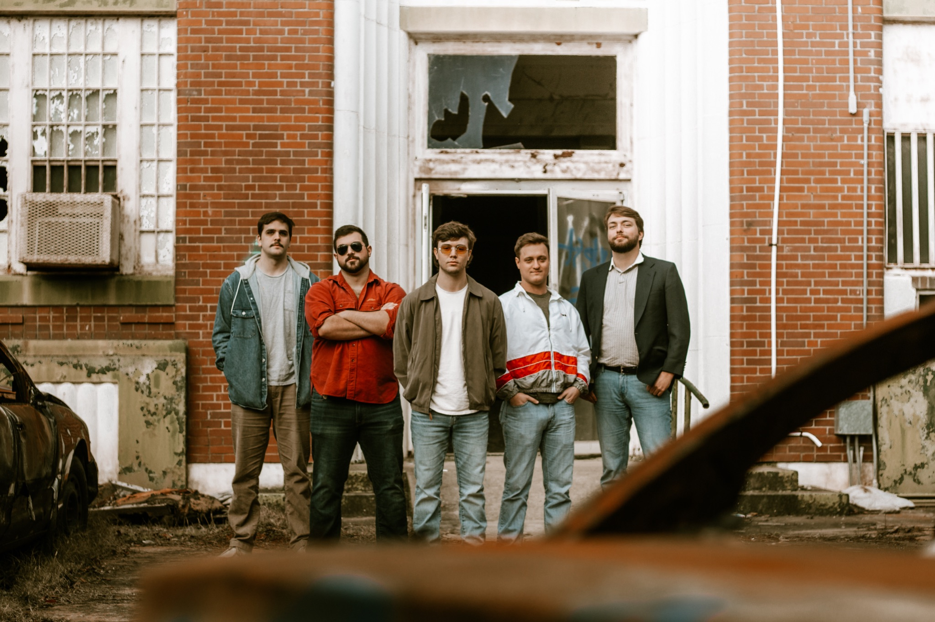

(Highway 49 members: left to right Lewis Ashe, Nathan Mulling, Layton Sheets, Denson Martin, and Hayden Spohn.)

When asked the question “How has it been juggling classes and the band?” Sheets answered by saying “Well most of us have already graduated but for those who aren’t, we try to schedule our dates around school because we prioritize our academics.” One of the members is a senior and the other is a recent graduate of Georgia College and State University. GCSU is located in the heart of Milledgeville, off of one of the major highways, Highway 49, which inspired the band’s name. The other members represent Mercer University, Georgia Tech, and Kennesaw State.

STARRING: HIGHWAY 49

**On the Road: Shows and Bros**

Highway 49 has played all over the state of Georgia, and even in surrounding states. Most of Highway 49’s shows are held in major well-known college towns like Athens, Milledgeville, Statesboro, Macon, and a recent addition Clemson. These shows are the ones that reel in most of the band’s profit, so they stick to playing these cities the most on their tours. So far this year, there have been 25 shows in the spring, 15 in the summer, and 12 at the beginning of fall with a remainder of 13 shows to finish off the year.

One of Highway 49’s favorite venues to play is at Southern Social in Statesboro because they get to meet up with old friends and it’s a “chill place to play our heart out and hype up the crowd with good vibes all around.” They also enjoy playing at one of their local bars, Buffington’s, in Milledgeville. The band all agreed that the reason they enjoy it most is that they always know the crowd and their friends are able to come to see them play. They also enjoy the fact that Buffington’s is where the band started. Before they became Highway 49, the group would attend Buffington’s open mic night where they found their love of playing live music for a crowd.

**Band Members to Family Members**

“We do plan to continue the band and playing after all members have graduated. It has been hard not being able to see our families as often as we used to prior to the tour, but when we play cities close to home, our parents normally meet up with us to cheer us on with love and support. Personally, my mom didn’t care for me to start touring around, but she knew it was a dream of mine so she supported me in making the decision.” says Sheets.

STARRING: HIGHWAY 49

After speaking to Sheets, I spoke with one of the guitarists, Nathan Mulling. Mulling has a girlfriend who attends Georgia College and works a part-time job in Milledgeville as a bartender. “Not only am I away from my family already at college and while on tour, but I am away from friends and my girlfriend. She travels with us to most of our weekend shows if her work schedule allows it but she does miss out on a lot. When we play our shows in Statesboro, I get to meet up

with my sister and a lifelong friend who I both grew up spending time with.” Nathan’s sister, Gracie Mulling, is a member of the Phi Mu sorority at Georgia Southern University. She told me how much she enjoys when Highway 49 comes to Statesboro so she gets excited to watch her brother take the stage. “He does what he loves and you can tell he is passionate about it so, being the good sister I am, I have to support him.”

**Long Live Rock and Roll**

Although Highway 49 plans to continue playing after all of the members have graduated, they don’t know exactly what their future holds. None of the members have majored in music so they think Highway 49 will become a part-time gig as they carry on with their “adult careers.” The members all hope that Highway 49 will sign with a record company sometime soon so they will be able to hit the ground running and not have to put a pause or possibly even a total stop to their music career. They love the thrill they get walking on stage and hearing the fans chant their names, singing at the top of their lungs, traveling across the state while seeing new things, but mostly the quality time the band spends together bonding at practices and on the road. The thought of losing those feelings is devastating to the members, but they are ready to accept the fact that Highway 49 may just be a college phase. “If Highway 49 does have to come to an end,

STARRING: HIGHWAY 49

at least we will know we played our hearts out and had the time of our lives with it. On a brighter note though, we have the rest of 2021 booked and already some shows in 2022 scheduled which are promising so far. We have been in contact with some connections about signing a deal with a local company but nothing has been set in stone just yet. We will accept what our future holds, whether it is Highway 49 or not, but until then, I’ve got a show to catch. I hope to see ya after the show Rylee, and remember, long live rock and roll.” said Sheets.